1. **Overview Section: (trend overview)**

* **Total Customers Affected- card**
* **Total Demand Loss (MW) – card**
* **Total outages**
* avg hours of shortage per event
* avg restoration hour (time pucket)
* **outages reported by year (count)**data status pie chart (may be a trend line)
* summary as a story tilling

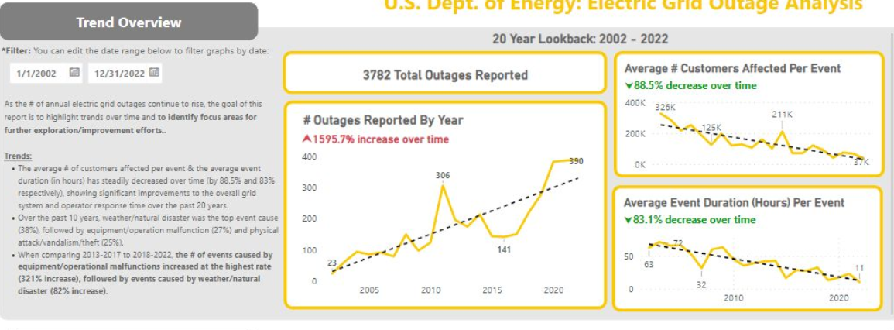

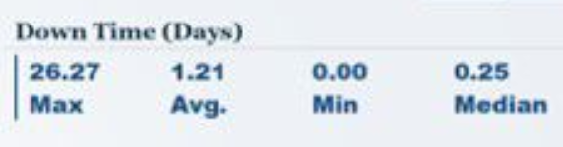

1. **Impact and Severity**: **لعرض تأثير الأحداث وشدتها.**

* Impact Score - number or percent in a card
* Event Severity Index (ESI) – maybe line
* Outage Risk Index (ORI)- Heatmap أو Bar Chart for regions
* performance over time:

demand loss by year #

customer affected by year

1. Regional Analysis: breakdown by geography

* nerc map with impact score in values
* **Event Frequency by NERC Devided By EVENT TYPE (satcked par chart)**
* Insights as a text.
* 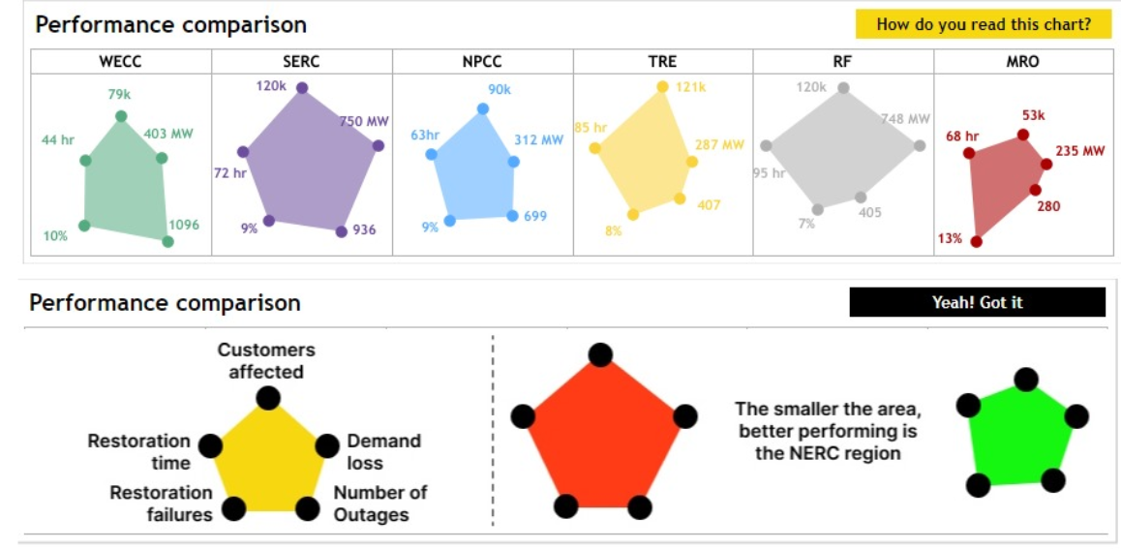
* **Heatmaps تظهر توزيع انقطاع التيار حسب المناطق المتأثرة ,**
* Outage Risk Index (ORI) by Region
* Number of total demand loss by region as a bar chart.
* Number of total customers by region as a bar chart.

1. Event Type Analysis

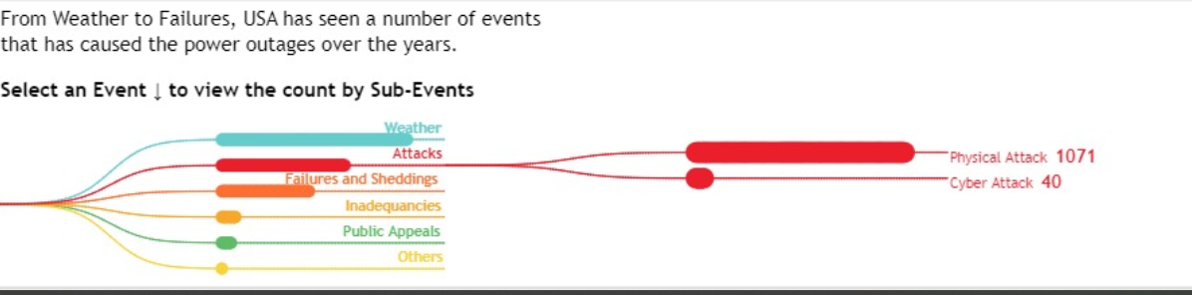

* Number of Events by Type
* Energy Loss per Event
* Number of Events by Type - Pie Chart
* number of events by year #

1. event reason analysis:

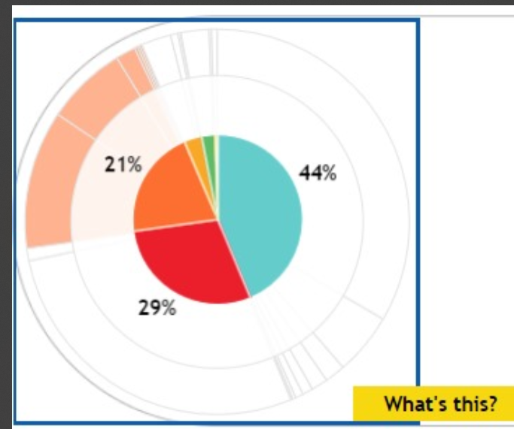

* of total events by reason
* of customers affected by reason
* demand loss by event reason

More :  
Total Customers Affected over Time  
Total Demand Loss over Time